***Blood Pact***

**by**

**The Epic Gamers**

**High Concept**

Blood Pact is a social deduction game, a retheming of The Resistance: Avalon by Don Eskridge and heavily inspired from Mafia and Coup (Board Game). The game sets the good side’s loyalists against the Vampire (Betrayer) collaborators. Players secretly take roles and must deduce alliances while completing missions.

**Genre:** A social deduction and secret role board game in which players must guess who to trust and hide their own role.

**Features**

· Loyalty cards make a second secret identity for every player that can be distinct from their character. This adds more bluffing, makes it more difficult to figure out roles, and keeps everyone guessing.

· Even when three missions are completed by the loyalists of the good side, the Vampires' Assassin has one opportunity to steal the victory by identifying the Church Leader.

· Due to the shifting loyalties, diverse role pairings, and social interactions, no two games will be the same.

· The players must debate and vote on which player is sent on each mission.

· Players secretly decide Success or Fail for each mission, maximizing tension in the game.

**Game Story: *The Curse***

* Long ago, nestled deep in the heart of the forgotten continent of Mystara, a hidden valley was discovered: Corven Hollow. This place was once said to be the final resting place of an Ancient evil, sealed away by the Church of Light over a thousand years ago. *But now, something is stirring…*
* Strange howls echo through the forest at night, locals disappear without a trace, livestock are found drained, their bodies cold and pale. An urgent message arrives at the High Cathedral. The Church assembles a sacred expedition to investigate the ruins and contain the threat. Among this group of explorers, however, 3 cursed souls have already succumbed to the darkness… THEY ARE VAMPIRES! Turned by the ancient evil sealed beneath Corven Hollow. They move in secret, aiming to weaken the group, sabotage the holy mission, and awaken the Ancient One.
* Only the Head of the Church, armed with a divine vision, knows the faces of two of these creatures. But his power is not perfect, and he cannot reveal himself openly without risking death. Somewhere among the group also walks a Vampire Hunter, blessed with fragmented knowledge: he has seen one vampire and the Church Leader but cannot tell which is which.
* As the party moves through the 6 sacred locations, they must decide who to trust. Each expedition could bring salvation… or doom. The fate of the world teeters on the edge of night.

**Concept Character Art: (only the Head of the Church and one Vampire developed as of right now) *SEE BELOW \** :)**

**Gameplay:** The game is played over 5-6 rounds (Expeditions).

· Setup: You’ll need 5-10 players.Give each person a Character card (Good or Vampire), special roles indicated on card (Vampire hunter, Church leader or Vampire), give out Yes/No vote tokens, and pick a random player to be the expedition leader for that round.

· Team Formation: The leader proposes a team, and the size depends on the round and the number of players. All players vote yes or no. If it passes, the expedition is undertaken. If the vote is unsuccessful, leadership passes clockwise. If five consecutive proposals are rejected, the Vampire team automatically wins.

· Expedition Resolution: The team reads the assigned Expedition story card, then all selected team players secretly play a mission card. Good loyalists always play Success, while vampire collaborators may play Success or Fail. However, Good loyalists may also put down Fail cards if they wish to purposely sabotage missions (for chaos or roleplay.) Reveal cards, if all players played Success, the expedition succeeds, if there is a Fail or two in some rounds then the expedition fails.

· Tracking: Place a marker for Success/Fail. The first side to reach 3 results wins.

· Endgame Twist: If the Good side reaches three successful expeditions, the Assassin makes their move to try and steal victory.

**Technical Development:** The game will be designed using online graphics and card design software (procreate and similar apps) and 3D print markers and tokens.

**Expected Audience:** Because of the vampire theme and the bluffing mechanics, we recommend it for players 12 years and up**.**

**Estimated Cost & Development Time:** Since it is a card and token game, the cost is low compared to video games.

**Risk Analysis**: This game is supposed to be played among people who are above the age of 12 at least. Because it might cause a negative impact on younger audiences and the theme might offend some groups of people.

*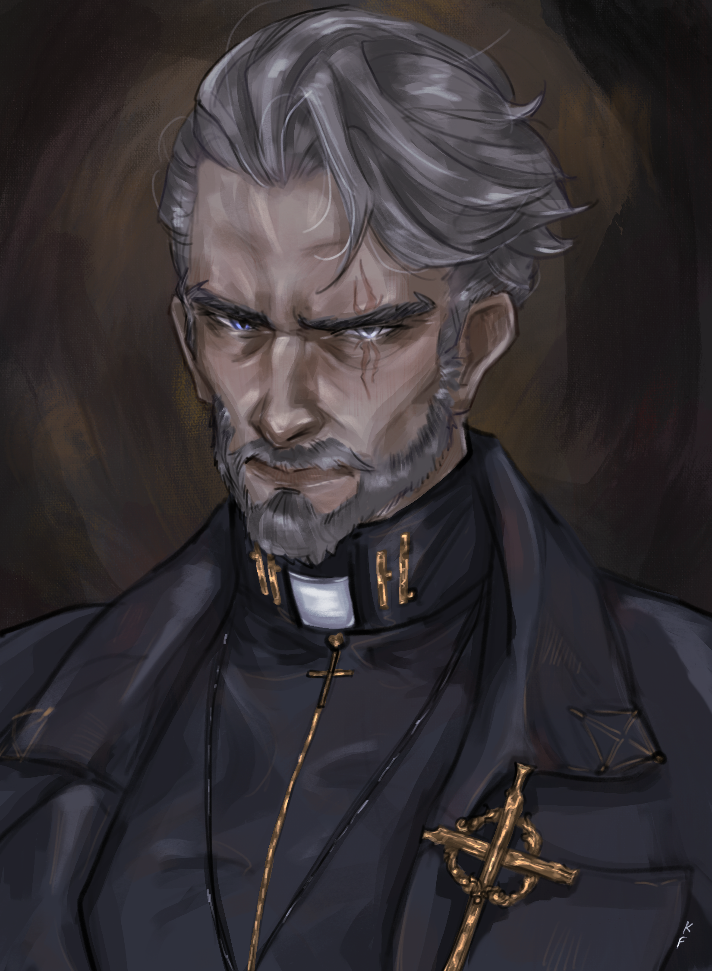[1]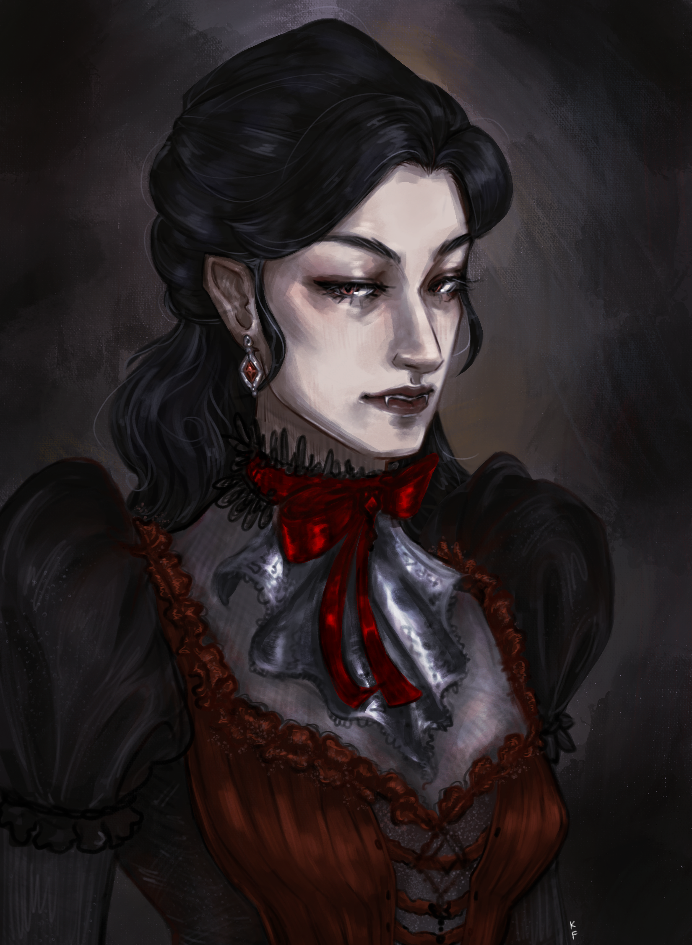[2]

1. Cardinal Alaric; The Head of the Church card art
2. Miss Isadora, Vampire Card Art